Programming Transact-SQL

Objectives
At the end of this session, the student will be able to:
- Using T-SQL
- Create, alter, drop functions
- Using system functions

Using Northwind database
- Create function named TotalAmount to display amount of money have to pay for the order. OrderID is the input parameter.
- Create function named NumberOfCustomer to return how many customers from the Country. Country is the parameter.
Call the function to check the result.
- Create a function to return list of products which have sum of selling quantity greater than 1000. Information of products includes :
ProductID, ProductName, UnitPrice, TotalSelling
Call the function to check the result.
- To calculate salary for salesman, manager would like to know total amount of money each salesman have been sold. Write a function to display information as follow :
EmployeeID, LastName, FirstName, TotalAmount
- Write a function to display infomation of product having the highest selling quantity in the specific month.
- Drop function TotalAmount.
- Display list of orders with the number of detail for each Order.

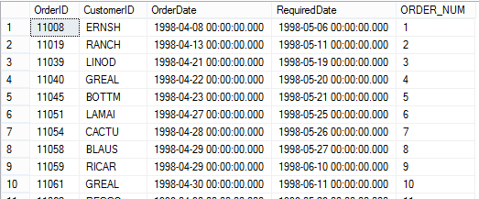

- Write a query to display CategoryId, CategoryName, ProductName, Amount of money has been sold and ranks of the products in each Category which are ordered by amount in descending order.
